# Team Assessment Profile

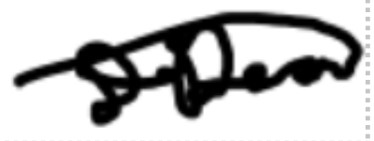

| **Student name (PRINT)** | **Contribution (Total work 100%)** | **Student (digital) signature** | **Design and implementation tasks\*** |
| --- | --- | --- | --- |
| DAVID DEAN | [21.25%] |  | * Poster (21.25%) * Mock-up (21.25%) |
| JACOB CORBETT | [21.25%] |  | * Poster (21.25%) * Mock-up (21.25 %) |
| AIDEN KERR | [21.25%] |  | * Poster (21.25%) * Mock-up (21.25%) |
| SAMUEL O’HANLON | [21.25%] |  | * Poster (21.25%) * Mock-up (21.25%) |
| TOLUWANIMI ADEYEMO | [%] |  | * Poster (%) * Mock-up (%) |
| LUKE SHERRINGTON | [%] |  | * Poster (%) * Mock-up (%) |
| ROKAS MATULEVICIUS | [%] |  | * Poster (%) * Mock-up (%) |
| **Total** | **85%** |  | **\*Where tasks were performed by two or more, state ratio of contribution after each task.** |

Students must ensure that ALL team members have signed this form and all agree with the declaration, before it is submitted with the coursework. In the event of disagreement, the course coordinator will have the final decision having met the team to discuss the matters of concern and reviewed the evidence provided by each team member. Any matters of concern raised after the submission deadline will not be considered.